**Greater Youth Resource Services, Inc.**

**DBA**

**Randolph Educational Collaborative**

**Youth**

**Mental Health First Aid Training**

***Collaboration with***

***Plymouth County Suicide Prevention Coalition***

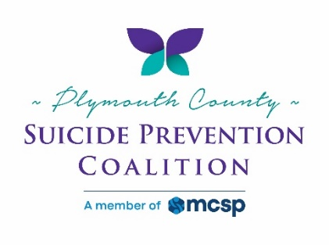 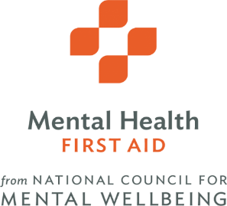

**[Must be 18+ to attend, FREE event]**

Similar to First Aid & CPR, this course prepares you to respond to youth and other individuals who may be experiencing a mental health-related crisis or problem. Topics include anxiety, depression, psychosis, and addiction. Learn what to say, how to use a 5-step action plan and whom to contact for more help. The National Council for Behavioral Health certifies individuals throughout the U.S to provide Mental Health First Aid courses to prepare their communities with the knowledge and skills to help individuals who are developing a mental health problem or experiencing a mental health crisis. Identified on SAMHSA’s National Registry of Evidence-Based Programs and Practices, the training helps the public better identify, understand, and respond to signs of mental illnesses.

**For more information on Mental Health First Aid Visit: www.mentalhealthfirstaid.org/cs/**

**DATE: Saturday, April 22, 2023 @ 9:00 AM – 4:00 PM**

**CO-HOST: First Congregational Church**

**1 South Main Street, Randolph, MA 02368**

**This program has been approved for 6.5 Social Work Continuing Education hours for relicensure, in accordance with 258 CMR NASW-MA Chapter CE Approving Program, Authorization Number D91551.**

**Actual value of class is $170.00**

**Trainer: Jennie Babcock For more information** *Email: –* *jbabcock13@comcast.net*

**To Register Contact:** **Brewsterj.edu@gmail.com** **Cell : 617-828-7340**

***Please RSVP by: April 15th or asap***

**Examples of sectors that may want to be trained:**

* Health and human service workers ● Educators and administrators
* Caring Citizens ● Human resource professionals
* Members of faith communities ● Mental health front line workers
* Parents & Caregivers ● Policymakers
* Nurses, PA’s, Primary care workers ● Homeless shelter workers
* Persons with mental illness & their families ● Social workers
* Police, First responders, corrections & security ● Coaches & Youth support staff
* Substance abuse treatment professionals